**IT2120-LabSheet-05**

**IT24102231**

**Rathnayake S.N.S**

**1)**

2)

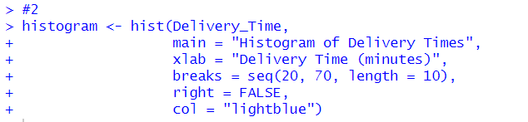

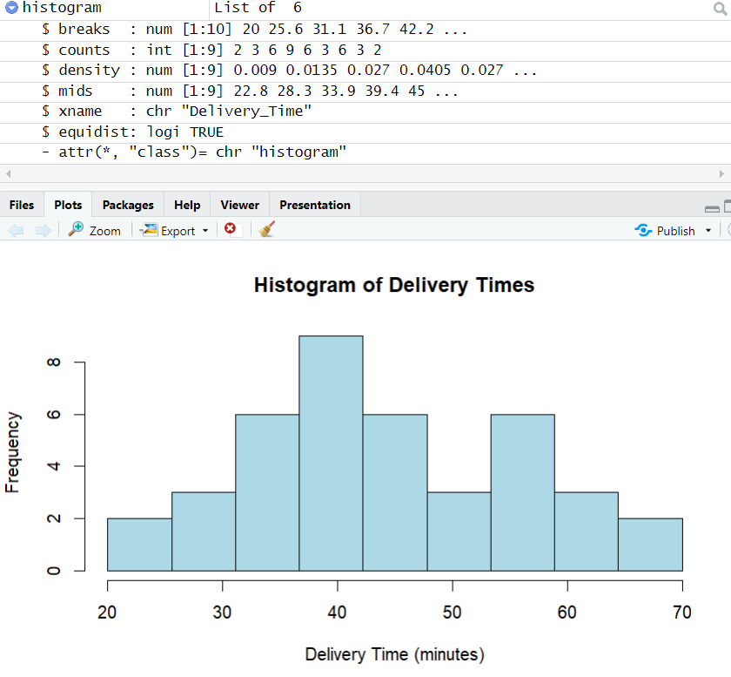

3)



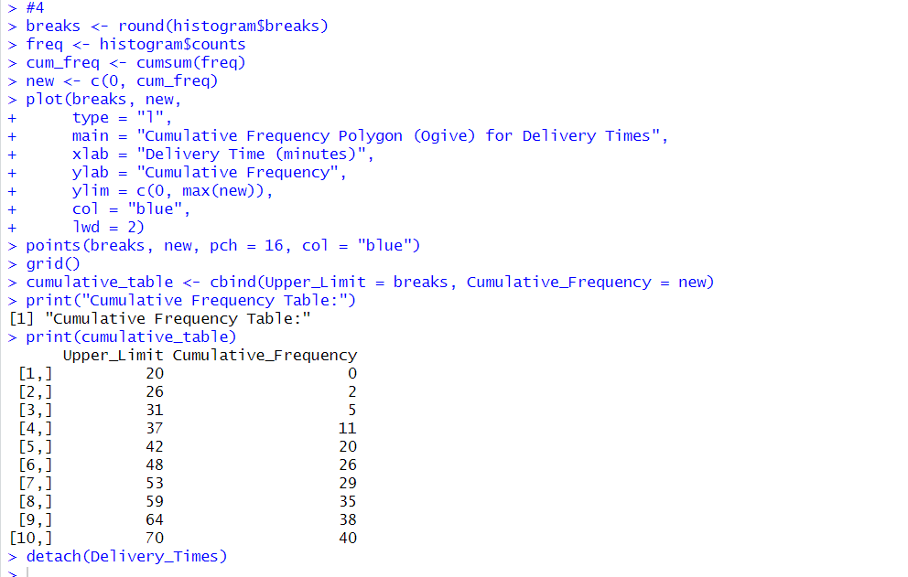4)

